**A/P INVOICES PAID VIA ACH**

1. In the vendor file, choose pay type (ACH) from pull down box. If this is set to ACH, then when selecting vendor invoices for payment through Payment Selection by due date (VB1) these vendors can be excluded from the run. This will allow those vendor invoices to be paid on a separate run.

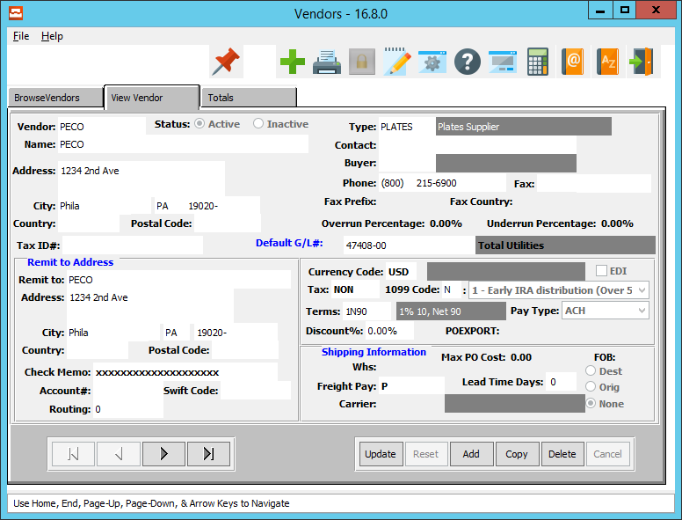

2. On the Select by Due Date screen there is a toggle box called [Payment Type].

When ACH is selected, then the payment selection by due date screen (VB1) will search all vendors with available invoices due within the terms. If that vendor has a payment type of ACH, then only those vendors will be included on the selection run.

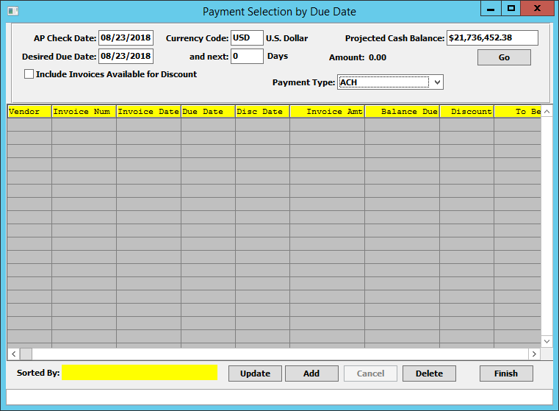

**STEPS TO PROCESS PAYMENT FOR ACH PAID INVOICE**

**Create an AP Check via VC1**. First select the invoice for payment (VB1or VB2) and then on the print checks screen (VC1), check the toggle box that says [ACH]. This will default the check starting at 8000000 range. This will be your starting check number for just ACH payments. The bank file will then store the new starting ACH check number as well as your normal check run range. Print the checks to plain paper or screen. If your check is formatted in Xprint format, you can print your check to the screen and then email a copy directly from Xprint.

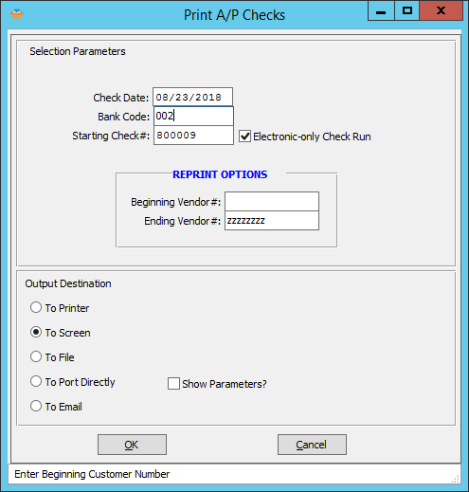

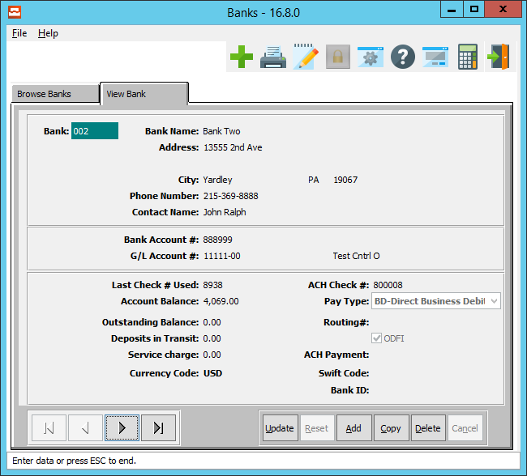

*New ACH check number range added to each bank file to store new ACH check number range. Check range must be 8000000 - 999999*